During an NDT *(*non-destructive testing*)* inspection, a crack is visually identified and located at stringer number 14 on the wing spar shear web.

Photos of the defect are provided; *we* are currently in contact with the manufacturerfor a repair disposition.

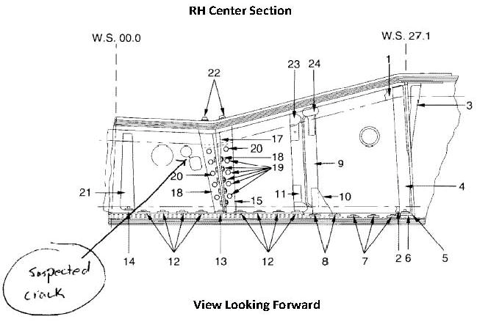

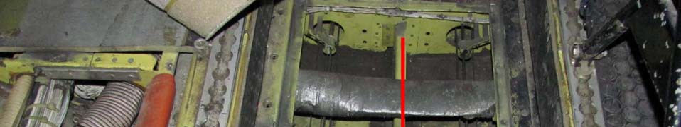

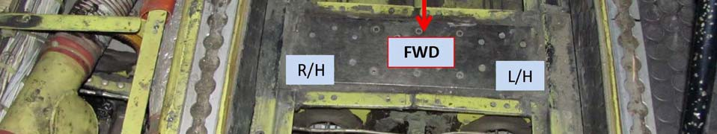

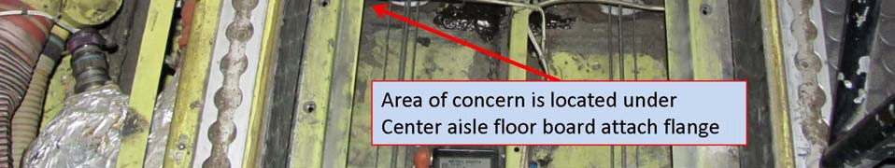

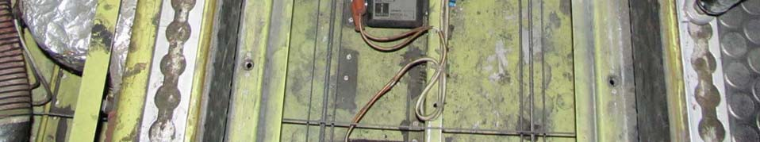

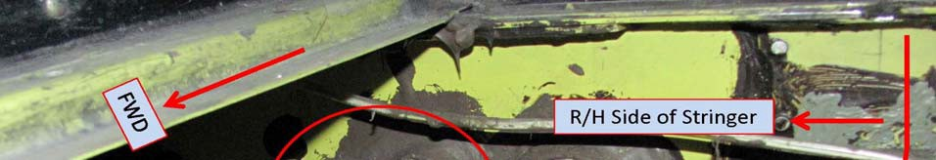

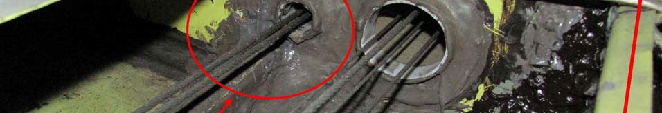

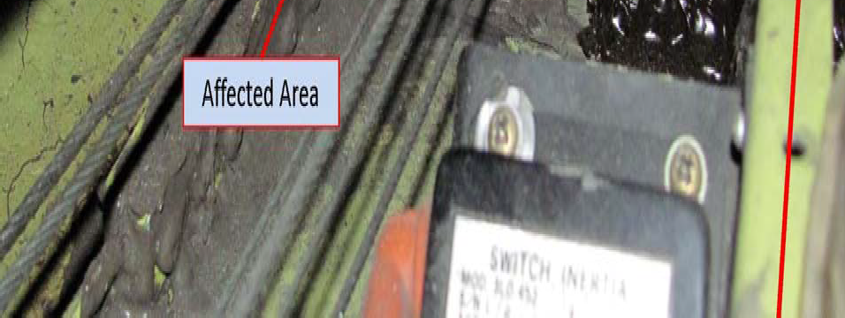

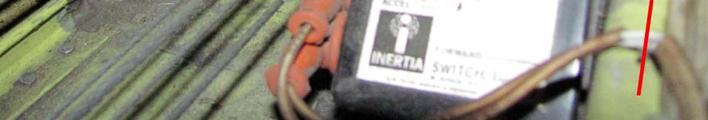

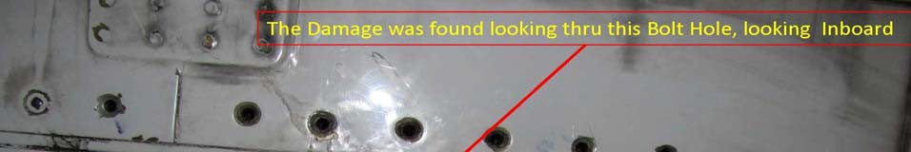

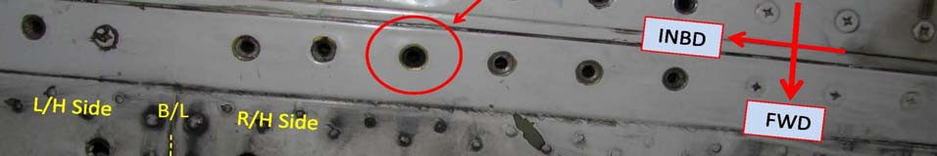

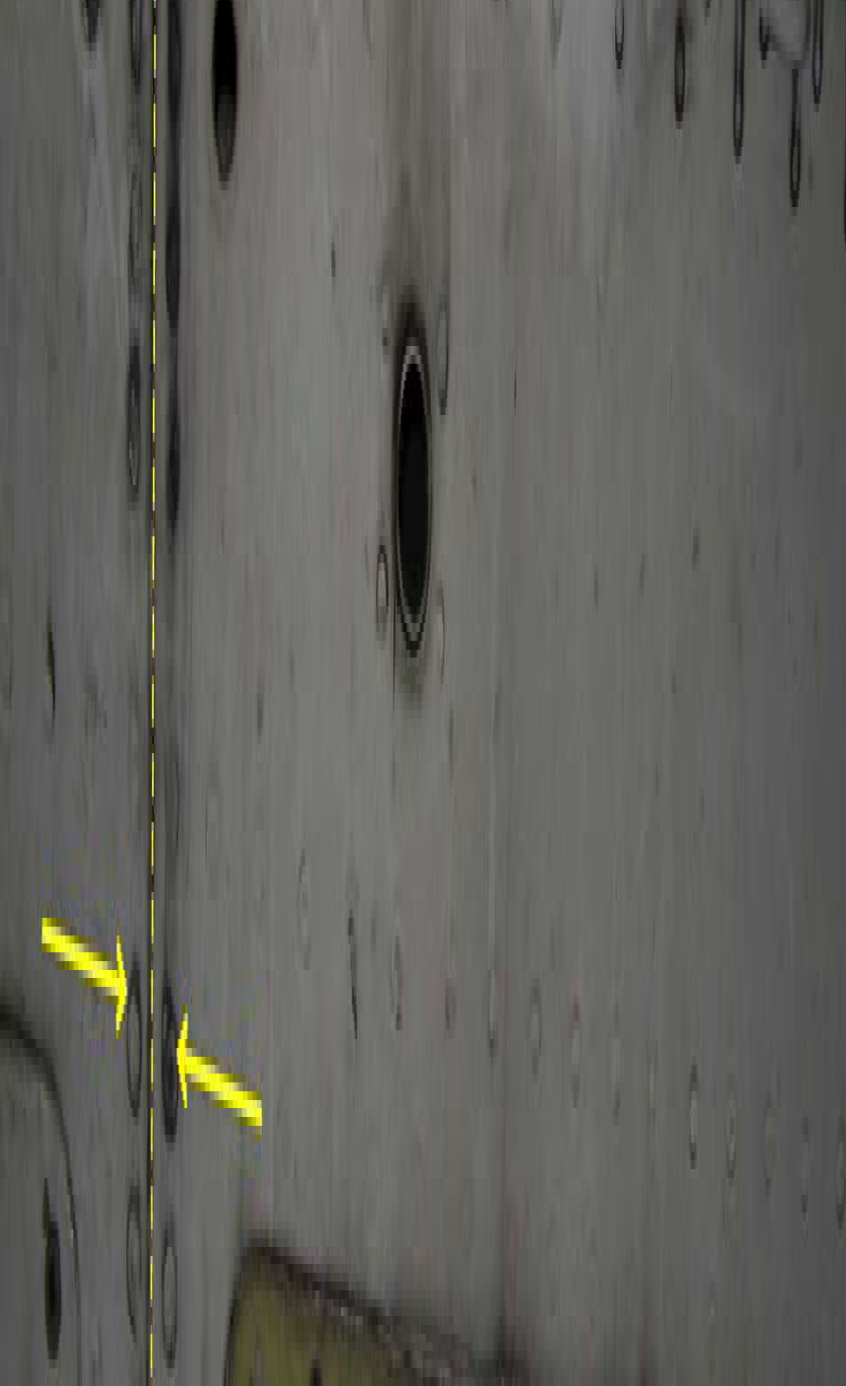

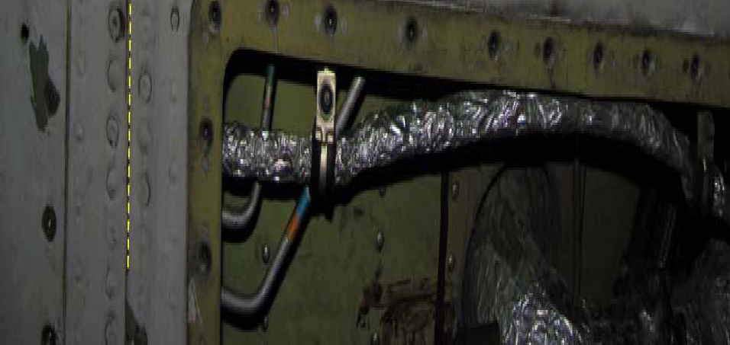

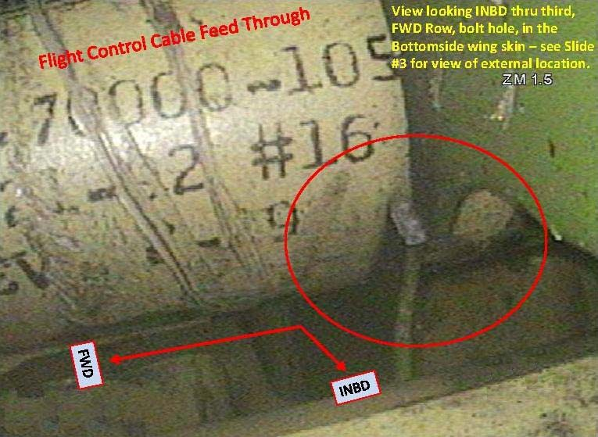

No part numbers were provided. Take a second look at the above, last photo: taken through the bolt hole.

Part Total Time: 29,756 hours